3.55: a) With 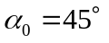, Eq. (3.27) is solved for 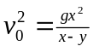. In this case, 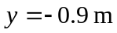 is the change in height. Substitution of numerical values gives 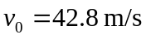. b) Using the above algebraic expression for  in Eq. (3.27) gives
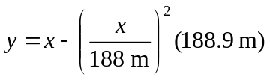
Using 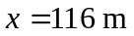 gives 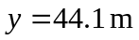 above the initial height, or 45.0 m above the ground, which is 42.0 m above the fence.

